1. **Poisson Distribution using R and Python**

**Aim :**

To write a program in R and Python to calculate probabilities using the Poisson distribution.

**Algorithm :**

**Step 1:** Start the process to implement the Poisson Distribution.

**Step 2:** Define the mean value (λ, lambda) based on the given problem.

**Step 3:** In R, use functions like ppois() for cumulative probability and dpois() for probability mass function. In Python, use poisson.cdf(), poisson.sf(), and poisson.pmf() from scipy.stats.

**Step 4:** Compute the probability of a specific event occurring (e.g., P(X=6)) using the formula or library function.

**Step 5:** Calculate multiple probabilities (e.g., P(X=0), P(X=1), P(X=2), P(X=3)) and sum them up.

**Step 6:** Display the results.

**Step 7:** End the program

**Program:**

**Using R:**

ppois(16, lambda=12,lower.tail = TRUE)

ppois(16, lambda=12, lower=FALSE)

lamda1=3000*0.001

k<-exp(-lamda1)*lamda1^6/factorial(6)

print(k)

dpois(6,lamda1)

k1=dpois(0,lamda1)

k2=dpois(1,lamda1)

k3=dpois(2,lamda1)

k4=dpois(3,lamda1)

c<-paste(k1,",",k2,",",k3,",",k4)

print(c)

print(k1+k2+k3+k4)

**OUTPUT:**

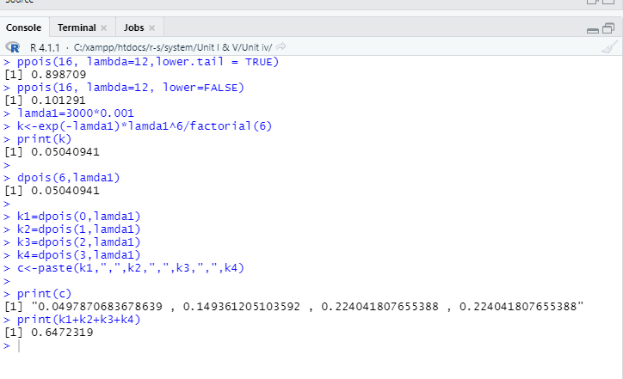

**Program:**

**Using Python:**

import math

from scipy.stats import poisson

p1 = poisson.cdf(16, mu=12)

print("P(X ≤ 16) =", p1)

p2 = poisson.sf(16, mu=12)

print("P(X > 16) =", p2)

lamda1 = 3000 * 0.001

k = math.exp(-lamda1) * lamda1**6 / math.factorial(6)

print("Manual formula P(X=6):", k)

k_scipy = poisson.pmf(6, mu=lamda1)

print("scipy P(X=6):", k_scipy)

k1 = poisson.pmf(0, mu=lamda1)

k2 = poisson.pmf(1, mu=lamda1)

k3 = poisson.pmf(2, mu=lamda1)

k4 = poisson.pmf(3, mu=lamda1)

print("Probabilities:", k1, ",", k2, ",", k3, ",", k4)

print("Sum of first four probabilities:", k1 + k2 + k3 + k4)

**OUTPUT:**

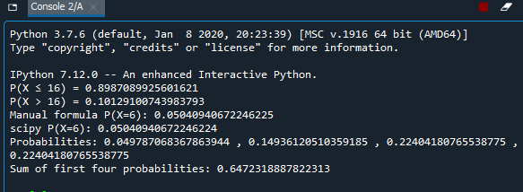

**RESULT:**

The Above program is executed successfully.